**ECCE paper potential references**

**\cite{Wang2013}**

J. Wang, Y. Li, and Y. Han, “Evaluation and design for an integrated modular motor drive (IMMD) with GaN devices,” *2013 IEEE Energy Convers. Congr. Expo. ECCE 2013*, no. Immd, pp. 4318–4325, 2013.

Series connected

Active voltage balancer

Interleaving yapmış, akım ripple ı % 35 düşürmüş. Cap size düştü diyor ama nasıl?

**\cite{Brown2007}**

N. R. Brown, T. M. Jahns, and R. D. Lorenz, “Power Converter Design for an Integrated Modular Motor Drive,” *Ind. Appl. Conf. 2007. 42nd IAS Annu. Meet. Conf. Rec. 2007 IEEE*, pp. 1322–1328, 2007.

5 phase-half bridge-common dc link

Two candidate IMMD dc bus architectures:

Inductance distribution figüre

simulation results- comparison of architectures

oscillations

experiment-both

**\cite{Wang2015b}**

J. Wang, Y. Li, and Y. Han, “Integrated Modular Motor Drive Design With <roman>GaN</roman> Power <roman>FETs</roman>,” *IEEE Trans. Ind. Appl.*, vol. 51, no. 4, pp. 3198–3207, Jul. 2015.

Loop inductance çıkarmış (power, driver, coupling)

Ron etkisini incelemiş ve Lloop ile Ron’u birlikte düşünmüş (overshoot için)

Interleaving yapmış (seri)- Cap size düştü diyor ama nasıl?

%1 ripple sağlamak lazım diyor, ana nerde?

They will be synthesized, and the ripples tend to get diminished by each other, resulting in smaller total dc-link voltage ripple amplitude => yanlış, zaten göstermemiş (akımda göstermiş, voltajdaki böyle olur demiş, ama olmaz)

**\cite{Zlwka}**

Yehui Han, “Design, modeling, and control of multilevel converter motor drive with modular design and split winding machine,” in *2014 IEEE 15th Workshop on Control and Modeling for Power Electronics (COMPEL)*, 2014, vol. 203, pp. 1–10.

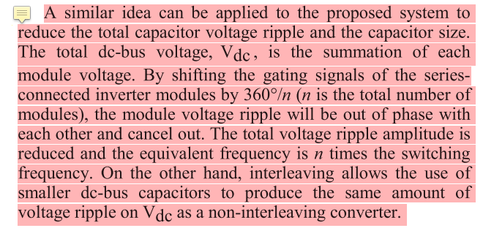

active voltage balancer

seri bağlıda interleaving ile dc link akım ripple ını düşürmüş

**\cite{Zhang2017}**

H. Zhang, L. Jin, O. Wallmark, and S. Norrga, “Evaluation of Modular Integrated Electric Drive Concepts for Automotive Traction Applications,” IEEE Transactions on Transportation Electrification, 2017.

stacked polyphaser bridge (SPB) => series (lv semiconductor, GaN), balance lazım

parallel-connected polyphase bridge (PPB)

Modülerlik => fault tolerance, small dc link capacitor

PPB-1: faz modüler

PPB-2: 3-faz modüler: bunda interleaving ile cap minimize edilebiliyor

[1] J. Wang and Y. Han, “A new concept of multilevel converter motor drive with modular design and split winding machine,” in *2014 Power and Energy Conference at Illinois (PECI)*, 2014, pp. 1–6.

Series connected

Balance lazım diyor ama devam etmiyor

dq set değerleri ile oyna

[1] A. Gkountaras, C. Dinca, A. Giedymin, P. Birgel, U. Schaefer, and S. Dieckerhoff, “Low cost integrated motor-controller drive for an electrical active suspension system,” in *2014 16th European Conference on Power Electronics and Applications, EPE-ECCE Europe 2014*, 2014.

power ve communication inductance tan bahsediyor

[1] G. Su and L. Tang, “A segmented traction drive system with a small dc bus capacitor,” in *2012 IEEE Energy Conversion Congress and Exposition (ECCE)*, 2012, pp. 2847–2853.

interleaving ile DC link ripple current düşürme (parallel bağlıda)